**SHIMONI DEMONSTRATION SCHOOL- KIRA**

**MID TERM TWO EXAMINATIONS, 2023**

**BABY CLASS ENGLISH**

**Name ____________________________________________________**

1. Colour these things at home.

 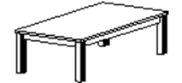

1. Match the same pictures.

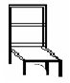 



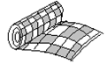

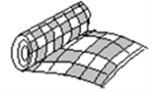

 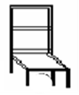

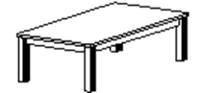

1. Colour these animals at home.

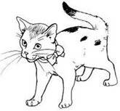 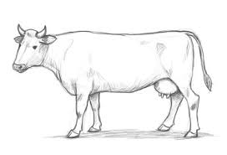

1. Match the same animals.

 